KC3HJP End-fed antenna

KC3HJP USA
Curtis L McCormick
507 Monongahela Ave
Elizabeth, PA 15037
USA
QSL: QSL Direct
Email: KC3HJP@arrl.net
home built end-fed antenna. The wire is 44' long 13.4m

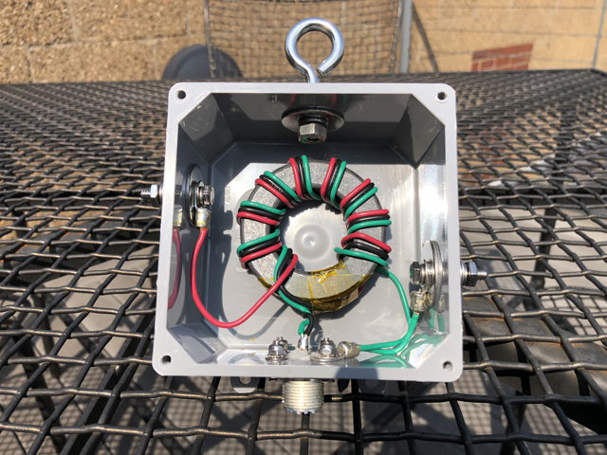

This is a 9:1 balun that I use with an LDG auto tuner. It’s nearly resonate on 20 & 10m at about 1.6:1. On the other bands the base SWR is higher before using the tuner but it tunes up fine.

In the picture the balun is just sitting on a patio table so that screen has nothing to do with the antenna itself, it’s just the top of the table. The left terminal is the terminal is that I connect the 44’ wire to. The right terminal is an optional ground terminal. I have mine connected to a 4’ ground rod just below where the antenna is mounted.

The story behind this balun is that I was using a commercially available end fed antenna and did really well with it. I had nearly 4400 contacts in a year and a half with it. About 3800 were on SSB phone and the rest were FT8. In that year and a half I only had 20 contacts on 80m. It was rated for 80m and it tuned up well but nobody could hear me very well. Another really strange thing was that it seemed like nobody could hear me very well on 20 & 40m after dark. I had very few contacts after 9pm. At the time I had only been licensed for a year and a half so I just thought that my lack of evening contacts was just the nature of the bands although I knew that I should have been doing better on 80 than I was.

Fast forward a little, I decided that I was going to try and build my own end fed for portable use. Well, I wound the balun and hung it next to my existing antenna and used the existing 44’ wire from the other antenna. When I put it on the antenna analyzer the results were more favorable than the antenna that I had been using. On many bands the readings in the analyzer were a little better and a few were just a little worse but not much worse. I ran 50’ of coax to it and setup a radio on the back patio and made contacts all over the world in a few hours. It performed at least as good as the other antenna but I only tried it on 40 & 20m.

For a week I kept thinking about this antenna and how it seemed better than my existing antenna. Unfortunately I had the other antenna sealed up with coax seal and electrical tape to keep the snow and rain out. If I was going to try to test this antenna for a long period of time with my radios I was going to have to unseal the original antenna and that coax seal is a real mess to take off.

Anyway I decided one day that I just had to see how this antenna performed. Surprisingly the coax seal wasn’t too bad to remove. So I hung this antenna and started testing it. One thing I noticed right away was that people could now hear me at night. Also, I started getting many unsolicited reports from people saying, “you are really loud” nobody every said that to me before with the old antenna.

The next thing that I noticed was a real shocker. I tuned it up on 80m just like the other antenna so I started trying to make FT8 contacts. Remember I only had 28 80m contacts in a year and a half with the old antenna. That night I made 32 80m FT8 contacts! I was completely shocked! Last month during the ARRL Field Day event I tried it out on 80m phone and had 20 some contacts that evening. So it’s completely solved my 80m issues.

When I took the old antenna down on April 28th of this year I had 4381 contacts on that antenna. As of today I have 6742 contacts so I’ve made 2361 contacts in nearly 3 months with this design. Just over half of those contacts are FT8 but that’s still pretty impressive. Another interesting thing is that on 30m it’s about 5.4:1 prior to using the tuner. 30m is this antennas worst band, at least looking at it on the analyzer. I actually have 100’s of contacts on 30m with this antenna so you can’t be afraid of what the analyzer reads, just let the tuner do its job. Some people get scared by the numbers but it’s really how it works when you goto use it. End fed antennas get a bad rap, typically from anyone that has never used one or who’s invested lots of money into their Mosley or Step-IR. Don’t get me wrong, and end fed is no Mosley but I’m working the same stations those guys are and I’m only using 100w.

I’ve since built a handful of these antennas for some local hams. Everyone is having great results with them. You can easily make one of these yourself. Just get an FT-240-61 toroid and wind it as a 9:1 balun with 16ga solid wire. Just be sure to buy a name brand ferrite core like Fair-Rite.

73

Curt
KC3HJP

End Fed Antenna Notes
(1) FT240-61 Toroid
(2) SO-239 Connection with bolts and lock washers
(3) 30” lengths of 16awg solid wire + 5 extra inches of green
(1) Junction Box (4x4x2”)
(1) 1/4x2” Eye Bolt (used as strain relief for main wire)
(4) 3/16x1 Fender Washer (wire and ground connections)
(2) 1/4x1” Fender Washer (for eye bolt)
(2) 1/4-20 Nuts (for eye bolt)
(2) 1/4-20 Lock Washers (for eye bolt)
(2) #10-24x1 Hex Bolts (wire and ground connection)
(4) #10 Flat Washers (wire and ground connection)
(4) #10 Lock Washer (wire and ground connection)
45’ 14awg Stranded Wire (loop through insulator and measure out 44’)
(1) Insulator (for end of wire)
(1) 1/8” Aluminum Ferule(for end of wire)
(4) #10 Yellow Lugs
(1) Small Blue Lug (wire and ground connection)
(1) Small Lug (ground wire on SO-239)
(1) GE Clear Silicone
(1) 3M Electrical Tape
(1) Kapton Tape
(1) Small diameter heat shrink

Wind ferrite core as shown. Leave 5” leader from the edge of the core out to the end of the wire before starting to wind the core. You will end up with at least 5” on the other end after 9 wraps through the core.

Mark each of the holes in the 4 sides of the box

Use an automatic center punch on each of the holes.

Drill a 7/64” pilot hole in the 4 sides of the box where you center punched.

Drill 3/16” holes for the wire and ground connections.

Drill the top and bottom holes out with a 13/64” bit.

Use the unibit and drill down 6 steps and just a slight bit with the 7th step.

Insert the SO-239 connector into the bottom of the box and mark all 4 of the holes and center punch them. Be sure you mark them with the solder cup facing up when you mark the holes. That’s the way you will solder it and for some reason with the connectors that I used this made a difference where the holes lined up when it came time to screw the connector down.

Drill the holes out with a 3/32 bit

Drill a 1/16” weep hole in the back right corner of the box.

Screw the eye bolt into top of enclosure and tighten down as tight as you can get it while compressing the lock washers.

Test for screws for SO-238 connector. They should thread the holes as you screw them in. Thread them in far enough to go into the inside of the box and then remove them. This step simply threads the holes.

Coat the outer edge of the SO-238 connector with silicone trying not to get any on the center conductor.

Lightly push the SO-238 connector into the hole and screw in the 4 bolts until the just snug up. Wipe any excess silicone off the ends of the bolts.

Put the nuts and washer on the two left bolts and the back right bolt. The front right bolt will be used to hold the ground wire down. Hold off on putting that nut and washers on for now.

Prepare the toroid by neatly covering the open edges between the leads of the toroid with Kapton tape.

Put Kapton tape on toroid where the following wires will be soldered. Solder the left black and the right red wires together using heat shrink to cover this joint.

Twist the left green and right black wires together.

Remove the yellow insulators from two of the #10 lugs and fill them with solder. I put them upside down between two paint sticks in the vise to do this. Try not to get any solder on the round part of the lug so that the surface remains clean, nice and flat.

Here’s another closeup picture

